**The Job Board**

A internal job board for a philanthropic technology company

# Presentation Date: December 9, 2020

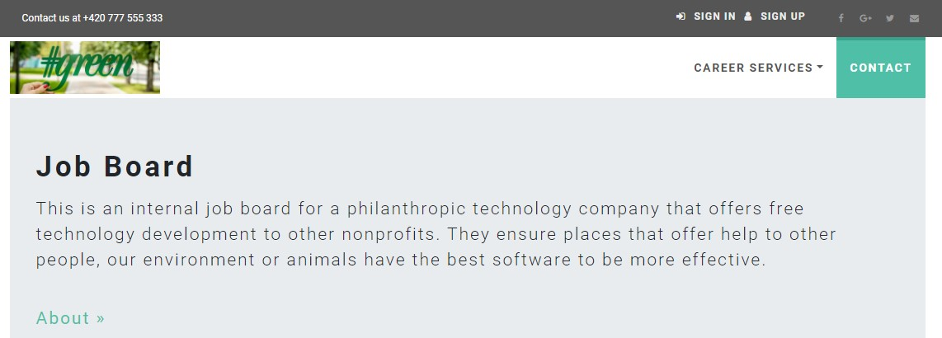

Ian Whitehill

# Full-Stack .NET Web Developer

## fsdp1.ianwhitehill.com

[whitehill.ian@outlook.com](mailto:whitehill.ian@outlook.com)

Dear Invested Reader,

Thank you for taking the time to read over this documentation for my final project at Centriq Training. I picked a job board for this 2 tier application because at the time of my writing I am looking to start my new career as a Web Developer. So, I have sent a lot of hours looking over job boards and company websites, must of which I found easy to and navigate. I really wanted to take on that challenge of building a solution that makes people want to work somewhere. A job board that inspired users to start a new career there passionate about not just a job to collect a paycheck.

This website is meant to be an internal job board that lets current employees apply for there dream job at there favorite company. I tried to use my new knowledge of the SOLID and DRY principal when coding, I also used a Kanban board to help me keep track of my progress. This was the first time I was able to program one application from beginning to end of version 1 without having to work on other projects. I really enjoyed that aspect of this process, I feel like it helped me see the program as whole, not just single pieces of functionality. It really grow my understand of the internal links in a ASP.NET, MVC and SQL.

The one thing I struggled must with over the last few weeks was ensuring users could only see the data that their role allowed them to. I did not want to create supported views for each role, so I pushed my understand of LINQ using both lambda and keyword syntax. There are so code snippets below with a good example in the applications controller of how I over this roadblock. For the most part I was able to work though must of the complications on my own my looking back at other projects. A few times I had to search stack overflow, ask the Instructor or a fellow student. I also had fellow students as me for help with their CSS and middle tier functionality mainly.

Thank you for your time, Ian Whitehill

## About the Author

I was previously in the Military where I worked with lots of different technologies both state side and oversea. During a deployment I was asked to help maintain and develop a process for issuing IDs to local nationals and third country nationals to properly identify and control access to current areas. We mainly did this through a local secured network and a few Excel spread sheets, however this was the first time I seal how powerful technology is in today’s world and realized I had a knack for it.

During my 5 years with Union Pacific Railroad, I had to learn a lot of technical information in a short time. There were weekly updates to rules, SOP and guidelines that I was required to stay update on and have functional knowledge of it. Due to the high demands of the job, there is high attrition rate for train conductors. I had 29 other people in my hiring class and only 6 of use where still working for UP in 2019. I was able to maintain efficiency by being disciplined and staying on top of changes.

Most recently I worked for a security company doing a lot of networking and managing different technologies. This experience really stocked my passion for IT, so I begin researching different areas in this field. I spoke with lots of different IT professional and tried different area like system admin and cyber security. After watching my first YouTube on how to write Python 101 I fell in love with wed development.

## Project Requirements

I was asked to build a 2 tier MVC application in the .Net framework using Microsoft SQL Server Management Studio and Microsoft Visual Studio. The focus of this application was to share job openings easily between multiple location and different user types. It needed admins to have full CRUD functionality on all areas of the application, managers to only have the ability view, edit and create specific data to there location and all employees to have crud functionality on their personal info, upload a resume and single click apply for open positions. The application also needed to be mobile friendly and geared toward internal job postings and applicants.

## Project

I started with requirements gathering by reading the brief and asking the Instructor for any areas of I needed clarification on. I then broke down the requirements into small manageable piece and add them to my Trello board.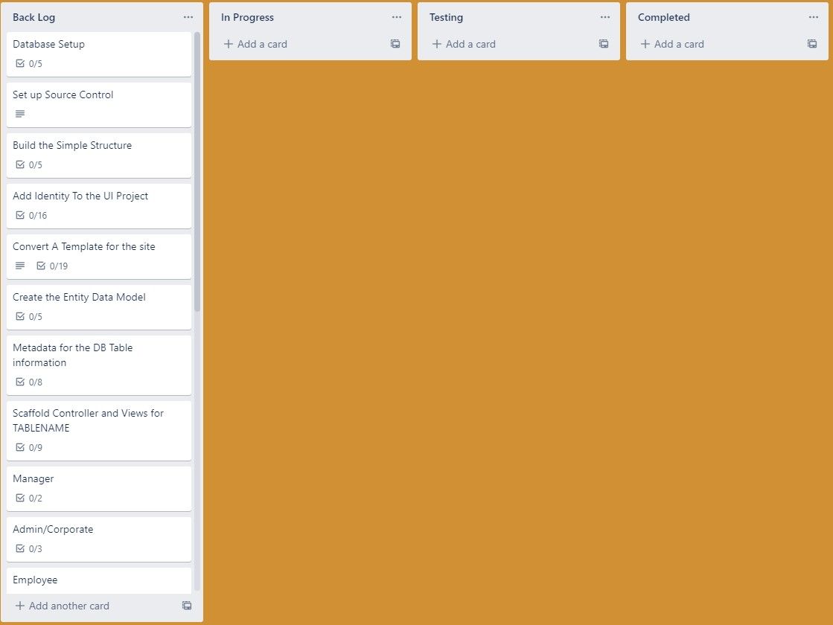

I then build my database in SQL and ensured my scheme would be able to handle all the data required for the application and possible data required version 2 of the application. I also populated all the tables with test data.

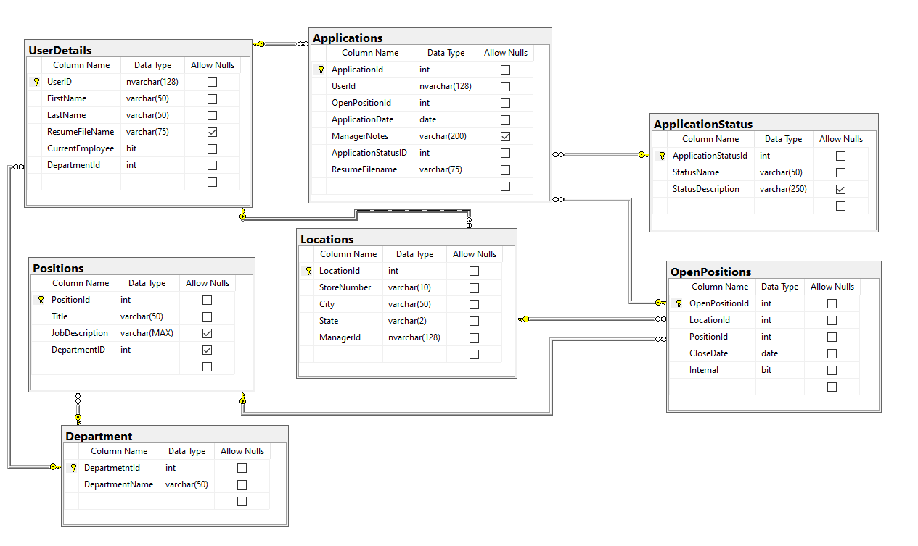

After finishing this I create a blank solution and linked it to my git repositor (<https://github.com/ianwhitehill/JobBoard>). My next step was to build out a base UI layer with authentication and linked it to my local data base. I sent a few hours trying to find a template I liked, would work well for the application and had more current versions of bootstrap and jQuery. I added a data project to my solution and link it to my database. I then add metadata and make a custom property for user details name.

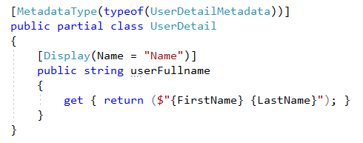

I then scaffolded out views and controllers for the tables and add the functionality for file upload. I wrote some Linq in the Application Controller to unsure Employees could only view there summited application, Managers could only view their summit application or application summited to open position at the locations and Admin could view all summit application.

Index Get

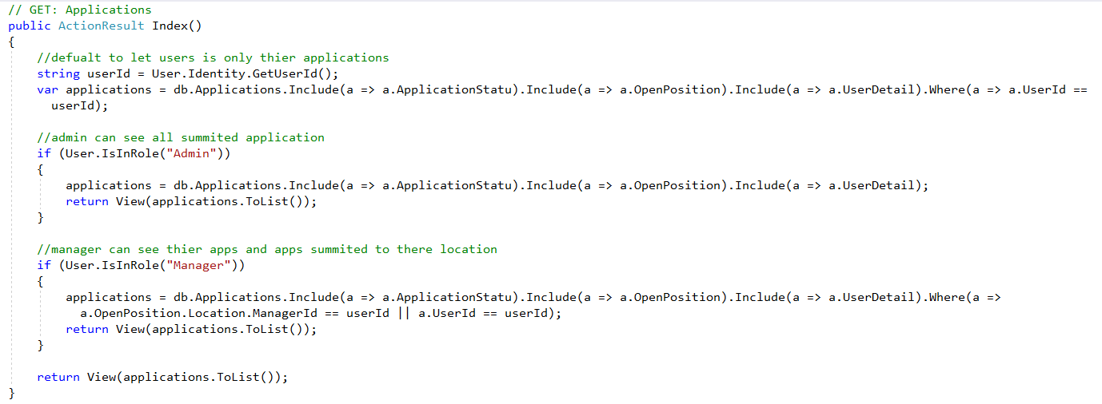

Summited Application Get (I created this view to pass an open position id and only get application related to that position)

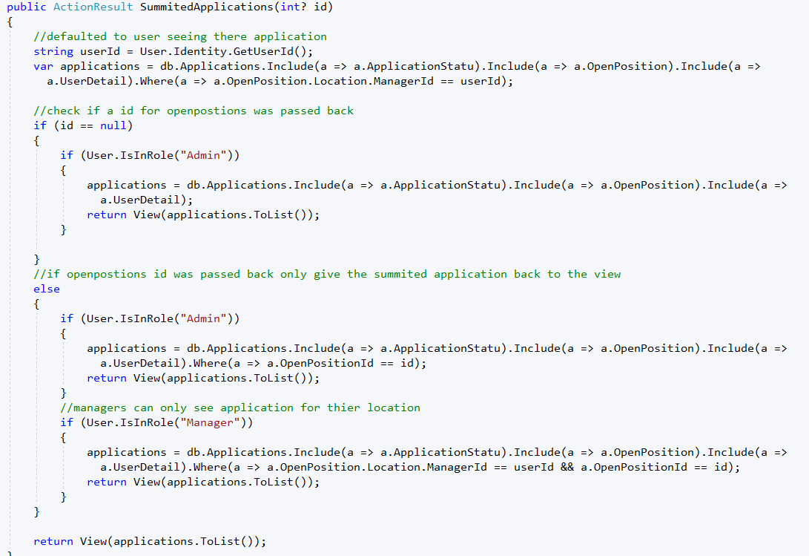

I also needed filtering to open position by location.

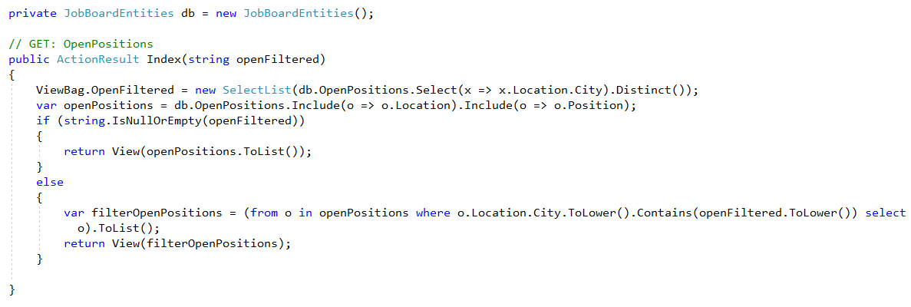

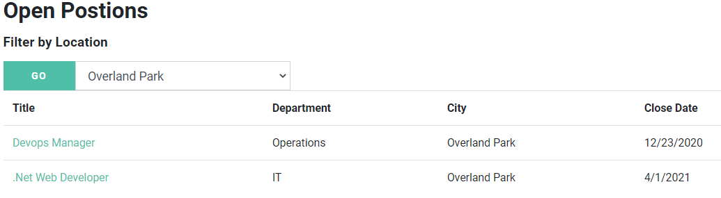

Here is a look at my use case diagrams

Anonymous Users

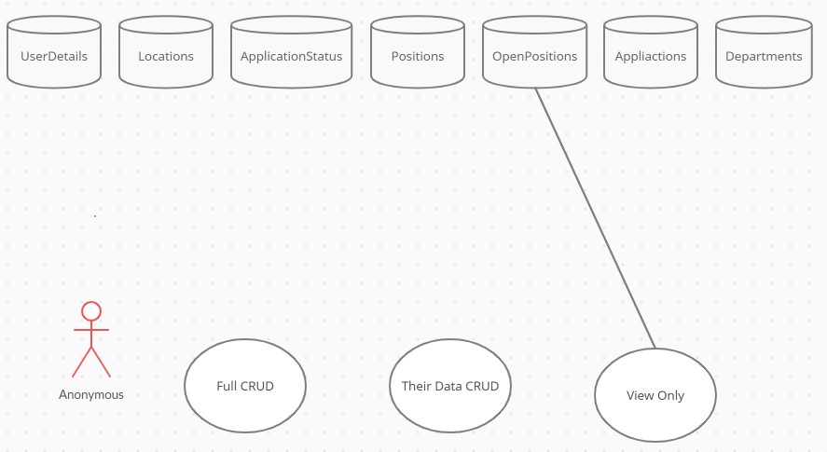

Employees

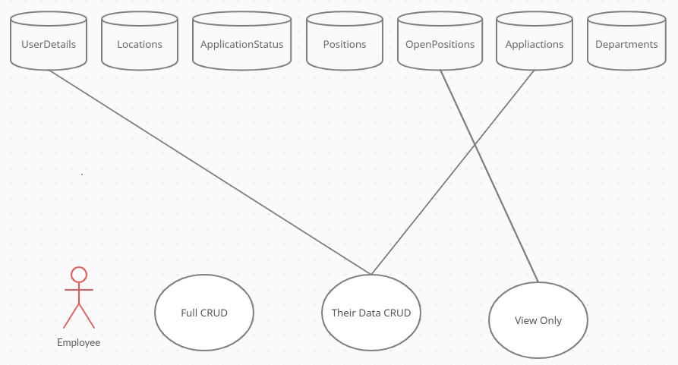

Managers

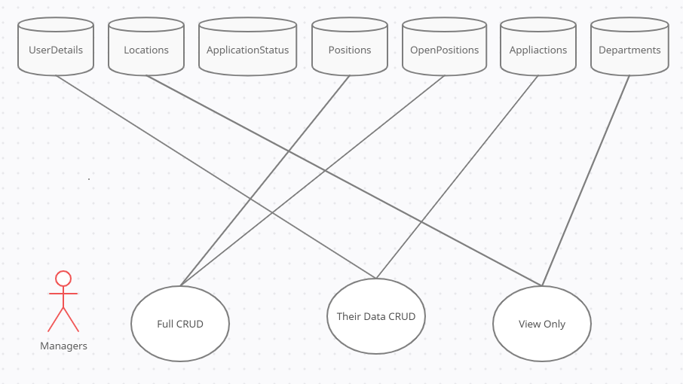

Admin

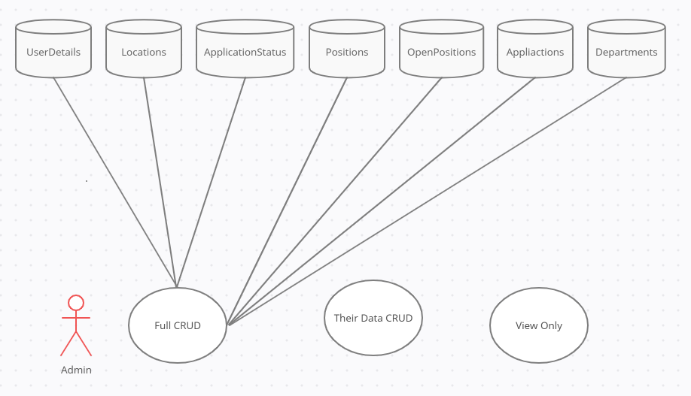

## Version 1.2

* Allow nonemployees to apply to external positions
* Add more filtering to open positions and summit applications
* Create an API
* Build iOS and Android apps
* Create a Department Manager role that can manage summited application at their location and department

Thank you for reading this I hope to get your feed back on this project and documentation. Please email me, connect with me on Linked or give me a call. I am open to any constructive criticism you may have or just networking.

